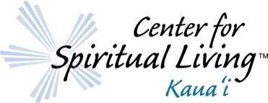
presents
The Quantum You Series
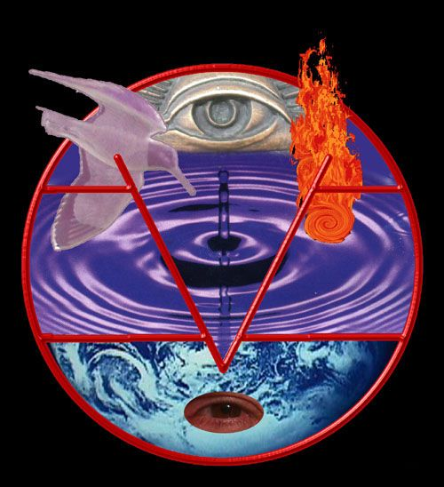
Discover the Science of YOUR Mind through Quantum Physics

“We look forward to the Day when Science will walk hand-in-hand from
the visible to the invisible.” Ernest Holmes

Join Revs. Rita Andriello-Feren and Rev. Patrick Feren for this exciting original series bridging Quantum Physics to the Science of Mind &
Live a more empowered life amidst the
challenges of today.

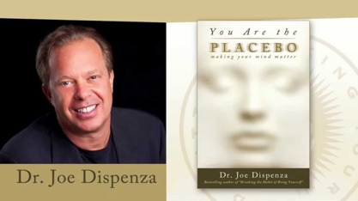
- You are the Placebo by Dr. Joe Dispenza – Sept. 15, 22, 29 2021 – 6pm to 8pm
“Your brain and body don’t know the difference between having an actual experience in your life and just thinking about the experience—neurochemically, it’s the same.” ― Joe Dispenza

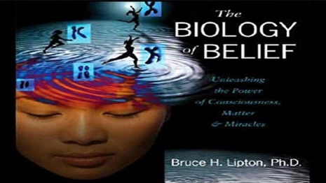
- Biology of Belief by Dr. Bruce Lipton – Dec. 8, 15, 22 2021– 6pm to 8pm
“We are not victims of our genes, but masters of our fates, able to create lives overflowing with peace, happiness, and love.” ― Bruce H. Lipton

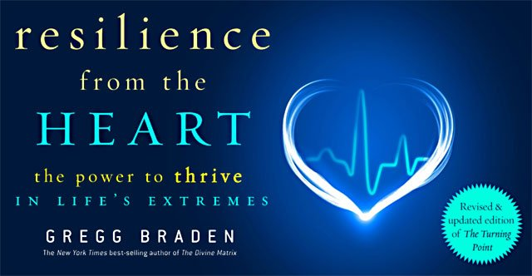
- Resilience of the Heart by Gregg Braden – Nov. 10, 17, 24 2021 – 6pm to 8pm
“Resilience of the heart is written with one purpose in mind. To empower us in the choices that lead to thriving lives in a new, transformed, and sustainable world.” Gregg Braden

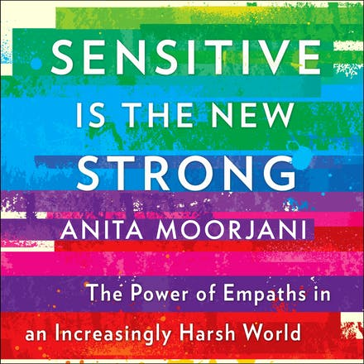
- Sensitive is the New Strong by Anita Moorjani – Jan. 12, 19, 26 2022 – 6pm to 8pm

“We have to identify and manage the things that jam our inner guidance system. And that involves turning down the volume on the outside world so we can hear what's going on inside.” Anita Moorjani

Each Series is sold in full for $75 – Payable in advance
www.cslkauai.org
Each series will be recorded for future reference or in case you miss a class.
Books will be available in the bookstore or on Amazon.

